Application for a SRUK Translational Award – Stage 1

Please complete your application in single line spaced Arial 12pt and submit it via email to grants@sightresearchuk.org by 23:59hrs on 31st October 2023.

Principal Applicant

Full name
Present appointment
Host institution
Contact details | Address:  Telephone:  Email:

Co-applicants: co-applicants are an integral part of the project team and share responsibility with the Principal Applicant for the day-to-day running and delivery of the project. Skip if you have none and add additional sections if you have more than two.

Full name
Present appointment
Institution
Email

Full name
Present appointment
Institution
Email

Collaborators: collaborators do not share responsibility for the overall management and delivery of the project but provide expert input on specific aspects of the proposed research. Collaborators can be sourced from any sector including neighbouring academic fields and/or industry. Skip if you have none and add additional sections if you have more than two.

Full name
Present appointment
Institution/Organisation
Email

Full name
Present appointment
Institution/Organisation
Email

Project details

Project title

Lay summary (max. 200 words)
Please include answers to the following questions:

- What is the background to the problem?
- What is the goal of your proposed research?
- Why does it matter to patients?

Scientific abstract (max. 400 words)
Please include answers to the following questions:

- What are the aims and objectives of your proposed research project?
- If successful, how will your proposed project advance progress towards patient benefit?

Keywords

Please enter up to six keywords that describe your application. Please separate the keywords with a comma.

Translational Readiness Level (TRL)

Please note that the Sight Research UK Translational Research Award only funds projects at TRL 5, 6, and 7. Please see the table in Appendix 1 for a breakdown of TRLs and further information in our Guidance for Applicants to help you answer the following questions.

- Which TRL does your proposed research project correspond to?

- Please justify the TRL you have assigned to your project (max. 100 words)

Background to the proposed research (max. 500 words)

Please address each of the following questions:

- What clinical unmet need are you addressing with the proposed research?

- What novel solution / technology are you proposing to meet the clinical need identified? (For example, is it a drug, device or diagnostic? Please summarise how it works).

- Are there competing solutions / technologies that are already available in the clinic or are currently being developed?

- What is the advantage of your proposed solution compared to solutions / technologies that are already available in the clinic or are currently being developed?

Project development description

Please provide the following information:

- Please outline the proof of concept data supporting this project (max 300 words).

- Proposed research project plan (please provide the outline structure of your proposed research plan, including broad milestones. Please also identify major risks and uncertainties and how these will be tackled – max 300 words).

- Please describe how you see the proposed solution / technology progressing towards clinical application, and the further funding you would need to secure to enable this (max 200 words).

Intellectual property

Have you discussed the potential commercialisation of your research with your institution’s Technology Transfer Office (or equivalent)?
YES/NO (please delete as appropriate)

Will your proposed project use human participants?
YES / NO (please delete as appropriate)

Project costs

Please note that the standard maximum duration for grants under this Award is 24 months, and the standard maximum value of the grant is £250,000.

If you need to apply for longer than 24 months, or more than £250,000, please contact our grants team (grants@sightresearchuk.org) before applying, to check whether your application would be eligible for your requested amount or duration.

Please tick whichever of the following applies to your project:

☐ I acknowledge that the maximum duration of the grant is 24 months.

☐ I am applying for longer than 24 months, and have spoken with the Sight Research UK grants team to discuss my project timeline, before submitting this application.

Please tick whichever of the following applies to your project:

☐ I acknowledge the maximum value I can apply for is £250,000.

☐ I am applying for more than £250,000, and have spoken with the Sight Research UK grants team to discuss my funding requirements, before submitting this application.

Proposed start and finish dates

Please note that awards will be made in early May 2024.

Start Date:

Finish Date:

Please ensure you have completed applicant CVs overleaf. Skip co-applicants’ CVs if you have none and add additional co-applicant CVs if you have more than one.

Principal Applicant CV (max 2 pages)

Name
ORCID ID
Current post(s)
If you are currently employed on a contract, contract end date
Email
Which of the following best describes your position |  | ☐ Academic researcher  ☐ Clinician  ☐ Clinical researcher  ☐ Other (please specify)
Previously held posts (most recent first, maximum 3 entries)
Start date | End date |  | Organisation | Position
Education and training (most recent first, maximum 3 entries)
Start date | End date |  | Organisation | Position
Previous applications to and grants awarded from Sight Research UK (previously National Eye Research Centre)
Grants awarded from other funders
Publications

Co-applicant CV (max 2 pages)
Skip if you have none and add additional co-applicant CVs if you have more than one.

Name
ORCID ID
Current post(s)
If you are currently employed on a contract, contract end date
Email
Which of the following best describes your position |  | ☐ Academic researcher  ☐ Clinician  ☐ Clinical researcher  ☐ Other (please specify)
Previously held posts (most recent first, maximum 3 entries)
Start date | End date |  | Organisation | Position
Education and training (most recent first, maximum 3 entries)
Start date | End date |  | Organisation | Position
Previous applications to and grants awarded from Sight Research UK (previously National Eye Research Centre)
Grants awarded from other funders
Publications

APPENDIX 1 – TRANSLATIONAL READINESS LEVELS (TRLs)

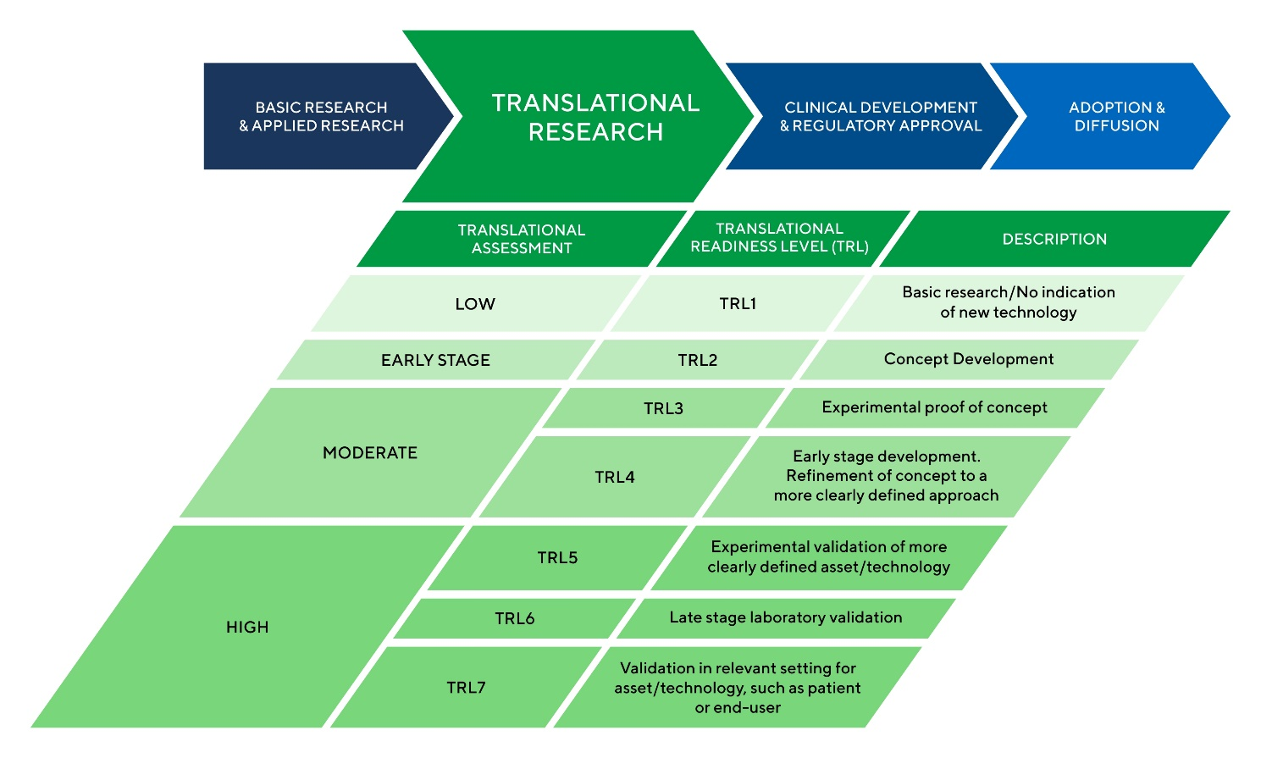

Please note that Sight Research UK’s Translational Research Award only funds projects at TRL 5 to 7.

For more information regarding TRLs please see our Guidance for Applicants.

If you have any questions regarding the TRL of your project, please email grants@sightresearchuk.org.

In addition to scientific review, applications will also be reviewed by our Board of Trustees which includes lay members. The Board of Trustees makes the final decision on grant awards so, to aid our final decision-making, please write the lay project summary using non-technical language. The following resources provide helpful information on how to write for non-technical audiences: - INVOLVE plain English summaries - The Plain English Campaign If you have further enquiries on the use of appropriate language, please email the Grants Management Team at grants@sightresearchuk.org.

