Application for a SRUK Translational Award – Stage 2

Please complete your application in single line spaced Arial 12pt and submit it via email to grants@sightresearchuk.org by 23:59hrs on 10th January 2024.

Please ensure that you also submit the Project Milestones and Costs form with your application. Failure to submit the form will invalidate your application.

Principal Applicant

Full name
Present appointment
Host institution
Contact details | Address:  Telephone:  Email:

Co-applicants: co-applicants are an integral part of the project team and share responsibility with the Principal Applicant for the day-to-day running and delivery of the project. Skip if you have none and add additional sections if you have more than two.

Full name
Present appointment
Institution
Email

Full name
Present appointment
Institution
Email

Collaborators: collaborators do not share responsibility for the overall management and delivery of the project but provide expert input on specific aspects of the proposed research. Collaborators can be sourced from any sector including neighbouring academic fields and/or industry. Skip if you have none and add additional sections if you have more than two.

Full name
Present appointment
Institution/Organisation
Email

Full name
Present appointment
Institution/Organisation
Email

Project details

Project title

Does this application relate to any grant previously funded by Sight Research UK?
YES / NO (please delete as appropriate)
- (If YES) Continuation of SRUK award number (e.g., SACXXX)
- (If YES) Completion date of previous grant
- (If YES) Please summarise the achievements of the previous grant and provide a list of any resulting publications (500 words max, excluding publications list).

Lay summary (max 400 words)

Please include answers to the following questions:

- What is the background to the problem?
- What is the goal of your proposed research?
- Why does it matter to patients?

Please also provide a summary of your research plan.

Scientific abstract (max 600 words)

Please include answers to the following questions:

- What proof of concept findings is your proposed research based on?
- What are the aims and objectives of your proposed research project?
- If successful, how will your proposed project advance progress towards patient benefit?
- If successful, how do you propose to exploit the results of the proposed research project?

Keywords

Please enter up to 20 keywords that describe your application. Please separate the keywords with a comma.

Translational Readiness Level (TRL)

Please note that the Sight Research UK Translational Research Award only funds projects at TRL 5, 6 and 7. Please see the table in Appendix 1 for a breakdown of TRLs and further information in our Guidance for Applicants to help you answer the following questions.

- Which TRL does your proposed research project correspond to?

- Please justify the TRL you have assigned to your project (max. 200 words)

Background to the proposed research

Please answer the following questions:

- What clinical unmet need are you addressing with the proposed research? (max 200 words)

- What novel solution / technology are you proposing to meet the clinical need identified? (For example, is it a drug, device or diagnostic? Please summarise how it works – max 200 words)

- Are there competing solutions / technologies that are already available in the clinic or are currently being developed? (max 200 words)

- What is the advantage of your proposed solution compared to solutions / technologies that are already available in the clinic or are currently being developed? (max 200 words)

- What is the current stage of development of your proposed solution / technology? (max 200 words)

Project development description

Please provide the following information:

- Proof of concept (please outline the key data that demonstrates the feasibility of your approach – max 400 words).

- Proposed research project plan (please outline your plan of investigation, methodology, and techniques – max 800 words).

- Milestones (please provide the outline structure of your proposed research plan by dividing the project in non-overlapping milestones. Please specify which milestones qualify as go/no-go decision points and provide SMART success criteria. Please identify major risks and uncertainties and how these will be tackled – max 800 words).

Please also complete the separate Project Milestones and Costs Form.

- Please describe how you see the proposed solution / technology progressing towards clinical application, including any regulatory considerations and commercial opportunities or barriers (max 400 words).

- Please describe the steps you need to take to secure more significant translational research funding (e.g., MRC DPFS, industry collaboration, etc. – max 400 words).

Intellectual property (IP) (max 600 words)

Please include answers to the following questions:

- What is the current IP status of your research?

- Have you discussed the potential commercialisation of your research with your institution’s Technology Transfer Office (or equivalent)?

- If so, what is their assessment of your proposed solution / technology’s commercial viability?

Will your proposed project use animals? (max 400 words)
YES / NO (please delete as appropriate)

If yes, what are your considerations for the 3Rs (Replacement, Refinement, Reduction)? Please note that this will form part of our peer review focus.

If YES, are the necessary Home Office project and personal licences in place? Please note that no award can be made until confirmation is received that the appropriate Home Office licences have been granted.

YES / NO (please delete as appropriate)
Will your proposed project use human participants?
YES / NO (please delete as appropriate)

If yes, have you already obtained the necessary ethical consent from the relevant bodies?

YES / NO (please delete as appropriate)

Sight Research UK is an NIHR Non-Commercial Partner.

Is your study eligible for adoption to the NIHR Clinical Research Network (CRN) portfolio?

Further information:
- NIHR CRN support eligibility
- NIHR Study Support Service

YES / NO (please delete as appropriate)
Project costs and timings

- Please complete the separate Project Milestones and Costs Form

Please note that the standard maximum duration for grants under this Award is 24 months, and the standard maximum value of the grant is £250,000.

If you need to apply for longer than 24 months, or more than £250,000, please contact our grants team (grants@sightresearchuk.org) before applying, to check whether your application would be eligible for your requested amount or duration.

- Please tick whichever of the following applies to your project:

☐ I acknowledge that the maximum duration of the grant is 24 months.

☐ I am applying for longer than 24 months, and have spoken with the Sight Research UK grants team to discuss my project timeline, before submitting this application.

- Please tick whichever of the following applies to your project:

☐ I acknowledge the maximum value I can apply for is £250,000.

☐ I am applying for more than £250,000 and I have spoken with the Sight Research UK grants team to discuss my funding requirements, before submitting this application.

- If you are not applying for the full cost of your project, please specify below where the funding for the shortfall is coming from.

- What % FTE will the Principal Applicant and Co-Applicants spend on this project, and what will their roles be within the project? Please specify if any other researchers will be working on the project along with their role and their % FTE.

Suggested reviewers

Please provide here names of potential peer reviewers. We will aim to collect a minimum of three peer reviews per application. The names you provide are useful guidance for our Grants Management Team, but we will also source reviews from experts you have not mentioned. These could include experts from neighbouring fields of research that have specific expertise relevant to your project.

Conflicted reviewers

Please state here the names of experts who may be conflicted in assessing your application (are frequent collaborators of yours, colleagues from the same host institution, etc.).

Please also state the names of experts who are direct competitors of yours and whom we should not share your application with. Please state if a whole research group at a particular institution is one that we should avoid contacting so that we do not share potentially sensitive information in a way that could be detrimental to your research.

References: please include a separate page (no more than one side of A4) for references relevant to the proposed project.

Principal Applicant CV (max 2 pages)

Name
ORCID ID
Current post(s)
If you are currently employed on a contract, contract end date
Email
Which of the following best describes your position |  | ☐ Academic researcher  ☐ Clinician  ☐ Clinical researcher  ☐ Other (please specify)
Previously held posts (most recent first, maximum 3 entries)
Start date | End date |  | Organisation | Position
Education and training (most recent first, maximum 3 entries)
Start date | End date |  | Organisation | Position
Previous applications to and grants awarded from Sight Research UK (previously National Eye Research Centre)
Grants awarded from other funders
Publications

Co-applicant CV (max 2 pages)
Skip if you have none and add additional co-applicant CVs if you have more than one.

Name
ORCID ID
Current post(s)
If you are currently employed on a contract, contract end date
Email
Which of the following best describes your position |  | ☐ Academic researcher  ☐ Clinician  ☐ Clinical researcher  ☐ Other (please specify)
Previously held posts (most recent first, maximum 3 entries)
Start date | End date |  | Organisation | Position
Education and training (most recent first, maximum 3 entries)
Start date | End date |  | Organisation | Position
Previous applications to and grants awarded from Sight Research UK (previously National Eye Research Centre)
Grants awarded from other funders
Publications

Signatures:
This application must be signed by the Principal Investigator and submitted with the approval of the Head of Department and the Finance Officer that will be responsible for the administration of the grant.
Principal investigator: | Name:  Signature:  Date:
I have read this application and confirm that, if successful, the project will be accommodated and administered in the Department/Institution and the infrastructure and support will be provided as described. I have read Sight Research UK's Terms and Conditions and confirm that they are acceptable.
Head of Department: | Name:  Signature:  Date:
Finance Officer | Name:  Signature:  Date:

APPENDIX 1 – TRANSLATIONAL READINESS LEVELS

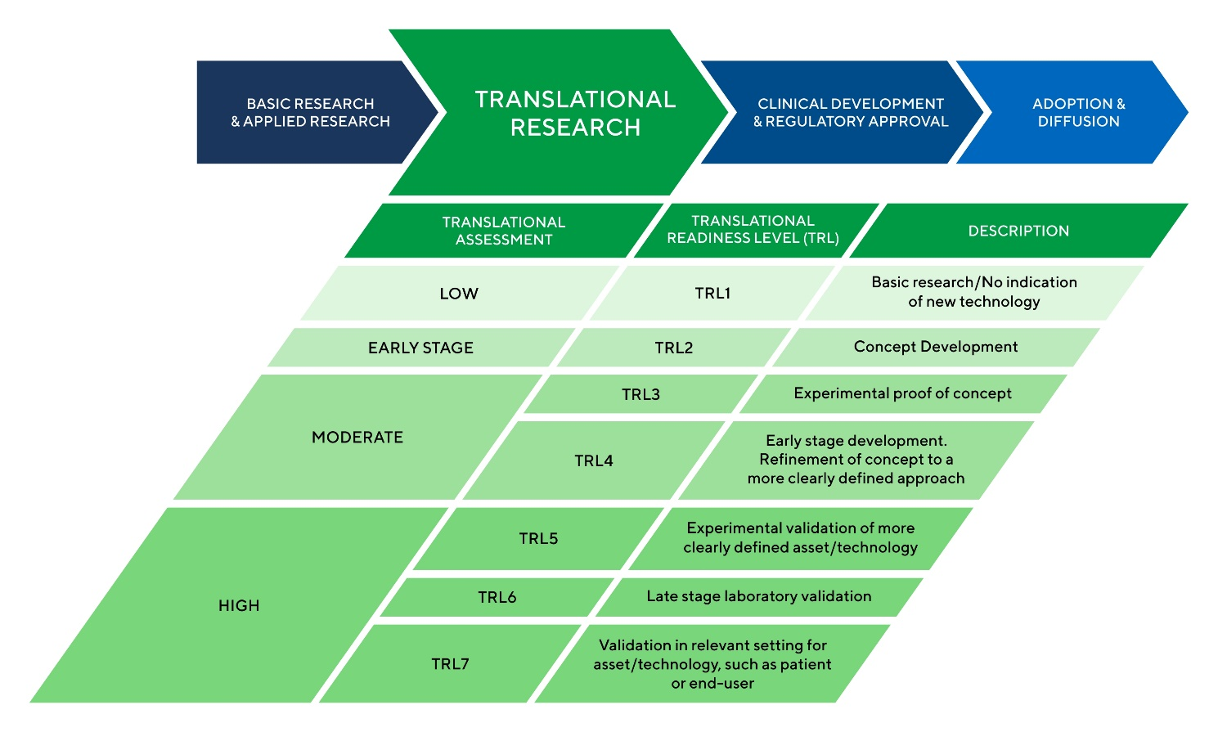

Please note that Sight Research UK’s Translational Research Award only funds projects at TRL 5 to 7.

For more information regarding TRLs please see our Guidance for Applicants.

If you have any questions regarding the TRL of your project, please email grants@sightresearchuk.org.

In addition to scientific review, applications will also be reviewed by our Board of Trustees which includes lay members. The Board of Trustees makes the final decision on grant awards so, to aid our final decision-making, please write the lay project summary using non-technical language. We may also use the lay summary in our marketing materials to communicate with our donors. Please aim for language suitable to explain the project aims to a 12-year-old child. The following resources provide helpful information on how to write for non-technical audiences: - INVOLVE plain English summaries - The Plain English Campaign If you have further enquiries on the use of appropriate language, please email the Grants Management Team at grants@sightresearchuk.org.

